1 | It’s an illusion…  - That you can control anything, other than how you choose to be. | 4 | It’s a paradox:  - We have to give up trying to control, in order to gain greater control of ourselves.
2 | You can’t control  - what happens to you  - how others behave, | 5 | So,  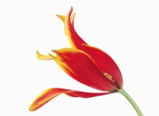  - accept things and people for how they are  - make a conscious choice of how you want to be instead
3 | You can control  - How you want to respond (“the last of the human freedoms” Viktor Frankl) | 6 | After all, in reality it’s never the event (or the other person) that’s the problem, it’s how you react to it/them that is!

